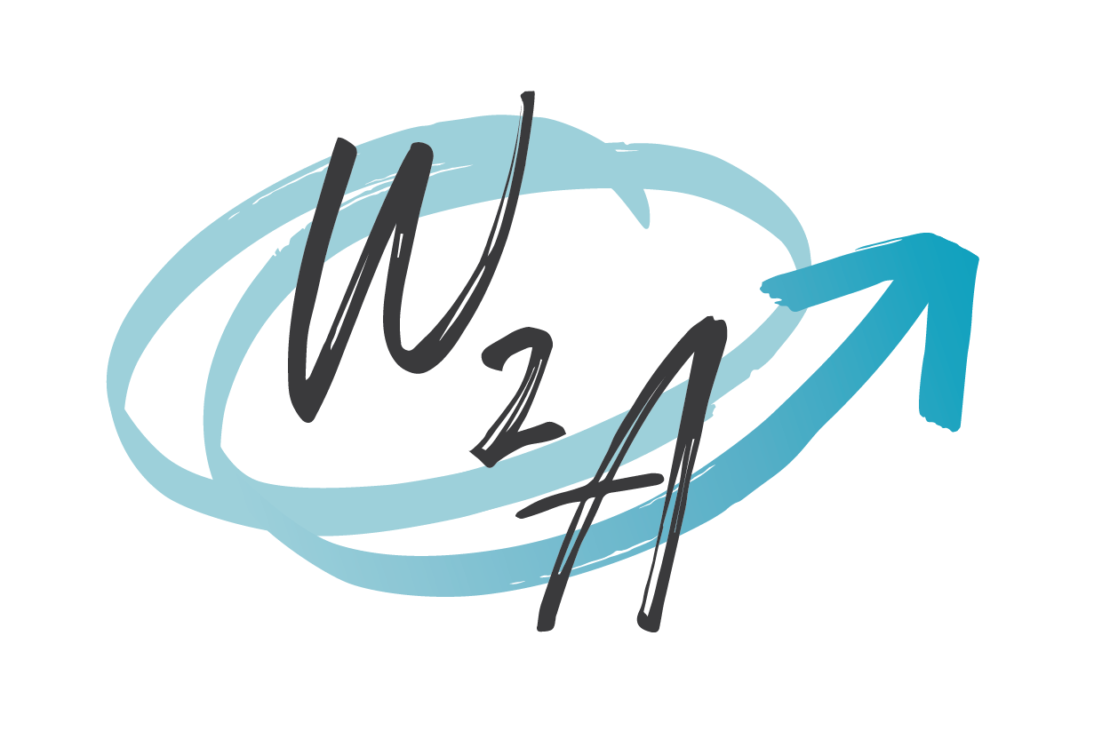

We’re Hiring!

Communications Manager
(Remote position/home-based)

Six-month term (three-month probationary period) with the potential of renewal
15hrs per week to start (flexible schedule) with the possibility to increase
$65,000/year (pro-rated)

Wisdom2Action is a consulting firm with a social enterprise commitment that works with non-profit and governmental organizations as well as other businesses to facilitate positive change and strengthen communities. Our work is primarily focussed on gender justice and 2SLGBTQIA+ inclusion, children’s rights and youth engagement, and mental health and substance use. Our work is aligned with, and guided by, our organizational values: anti-oppression, community driven, and evidence based.

We are seeking a Communications Manager to fill an important role for our business. The ideal candidate will have a minimum of 3 years in a similar role with demonstrated experience in:

- Editing final reports for grammar, syntax, spelling, and formatting
- Preparing visually appealing final reports and other knowledge products in line with AODA guidelines
- Preparing communication and marketing plans to promote projects, activities, and/or events
- Preparing content for and maintaining multiple social media accounts on multiple platforms
- Preparing op-eds, social media posts, media announcements, blog articles, and other knowledge products for a wide variety of audiences
- Facilitating webinars or in-person events
- Responding to media requests, interviews, and other forms of public engagement
- Establishing and maintaining positive relationships with partners, vendors, and clients
- Creating and maintaining webpages using WordPress or other similar platforms
- Working remotely, independently, and collaboratively with strong time and project management skills

We also seek an individual who has a demonstratable commitment to anti-oppression.

English is primarily used in our work however preference will be given to candidates who are proficient (read, write, speak) in both English and French.

The position is home-based/remote. No relocation is required. Applicants must have a workspace that protects the privacy of work-related activities including meetings held via Zoom. Use of a personal computer and reliable internet access are also required the cost of which will not be paid by W2A.

W2A is committed to employment equity and encourages applications from individuals impacted by colonialism, racism, classism, sexism, able-ism, trans-phobia, homophobia, bi-phobia, or other or multiple forms of oppression. Preference will be given to Black, Indigenous, and racialized queer and trans people, as well as qualified candidates with disabilities, who are neuro-diverse, or are new Canadians legally entitled to work in Canada. Self-identification by candidates is completely voluntary using the form accompanying this positing.

Applications will be considered on a rolling basis until the position is filled. Your application should include your CV, contact details for two professional references, and a cover letter, merged into one PDF document. Your cover letter should explain:

- Why you are interested in the position
- How your experience qualifies you for the role
- Your preferred start date.

Applications and/or questions should be submitted to info@wisdom2action.org with “Communications Manager Application” in the subject line of the email.

Applicants are invited to complete the Self Identification form posted alongside this advertisement. Only short-listed candidates will be contacted to arrange an interview.

Other Opportunities
Applicants may also be interested in a similar role with our sibling organization the Society of Queer Momentum (Momentum). More information about that position can be found at: www.momentumcanada.net/hiring. Interested applicants should follow the guidelines for that posting and demonstrate how their experience meets the requirements of that posting. Wisdom2Action and Momentum are two separate organizations. Successful applicants will be contracted independently.

